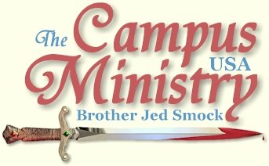
brojed@aol.com
brojed.org
cell:573-999-0346
573-999-0346
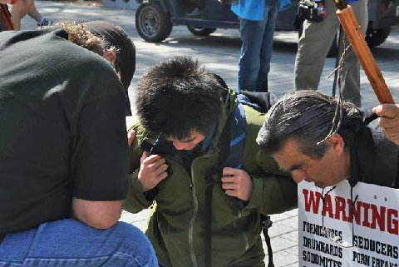

“GOD IS BYOND GOOD AND EVIL”

UCLA, February 28, 2011,

“God is beyond good and evil,” a passerby yelled at me. This is a popular misconception of God in such a bastion of moral relativism as a University campus. On the other hand, Jesus said, “There is none good but one, that is God.”-- Matthew 17.
And our Lord said of himself, “I am the good shepherd . . . and I lay down my life for the sheep.”—John 10:14-15.
Averroes, whom I debated last week, said, “You cannot define God.” If God cannot be defined than God is nothing. We have a God who is holy and knowable.
The student comment was made as I was arguing with a girl who identified herself as a Hindu. She said, “Hindus are tolerant of all religions.”
I responded, “I doubt the tolerance of Hinduism. Nevertheless, the God of the Bible says, ‘Thou shalt have no other gods before me.’ God is intolerant of an idolatrous religion like Hinduism which considers cows to be sacred.”
Keith Darrell requested to preach with me today. Keith first heard me as a young Christian at Bowling Green State University in 1993. He had been studying Calvinism and was already dissatisfied with their soft approach to evangelism. Keith testifies that Christians would ask him what he thought about Brother Jed who preached in front of the Student Union. He would respond, “I do not agree with everything he teaches but he has opened up many opportunities for me to witness.”
Keith finished his undergraduate work at Miami University in Ohio. He always had challenging theological questions for me. Keith went on to seminary and graduated from Covenant Seminary in St. Louis. Keith did some campus preaching on and off over the years and then worked for a number of years in finance in NY. Recently, he gave up his lucrative career in finance to travel and preach on college campuses full time. He is a Presbyterian. We have maintained a Whitfield/Wesley type relationship of mutual respect over the years. Someone asked Keith today about original sin. Keith later said he wasn’t sure how to respond. I told him, “Go ahead and explain the issue according to your understanding. When I take my turn, I will probably have the opportunity explain my take on the issue. We will let the students sort it out.”
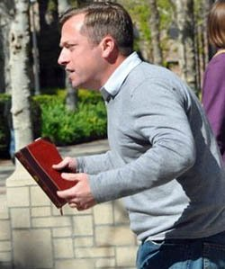
Brother Keith Darrell
We had difficulty getting the students attention today. UCLA can be like that. Ruben, who is hosting me in LA, said it best, “UCLA is a bipolar campus; sometime one can have great meetings there other time not much happens.”
Finally, shortly before 3 PM, I was able to gather about a dozen students with the help of a boy that Martha referred to as “psycho.” He wanted me to preach on God’s love. He even got on his knees and prayed. Then he had the audacity to say, Jesus said, “Not to preach on the street corner.” I corrected him, “Jesus said not to pray in the streets to be seen of men.” Soon he was off to the side in a fetal position and crying.
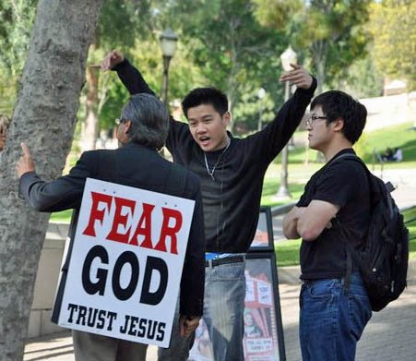
"...he had the audacity to say, Jesus said, 'Not to preach on the street corner.' "

"Soon he was off to the side in a fetal position and crying."
Other Christians said, “I appreciate what you are trying to do, but . . .” There is usually the “but” connected with what positive feedback that I might get, except for one freshman Christian, who was very positive concerning our ministry.
At 3:50 I called upon Keith. He handled the Christians with finesse. He took the angle that there are different callings and gifts in the body of Christ that we should respect. He admitted that he was usually more accepting of Christians who emphasized social justice over saving lost souls or took different approaches than they were towards him.
Martha and I had to leave at 4:15 for an internet TV show out of Paramount, CA hosted by David Hernandez, who is a young evangelist, associated with the Praise Fellowship churches. He said from the research and interviews that he has done I was instrumental in promoting a revival in their fellowship when they were in their beginnings in Maywood, CA.
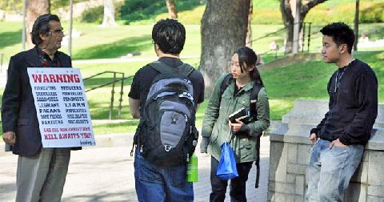
"UCLA: A Bipolar Campus"

THE BAPTIST, THE PRESBYTERIAN AND THE PENTECOSTAL

Cal State Fullerton, March 1, 2011

Pastor Jack, who is evangelizing in California, formerly ministered at a Baptist Church back in Minnesota. Years ago, he had me preach for him. He said he got a lot of flak from his congregation for inviting me.
Keith met us again today. So we had a Baptist, Presbyterian and Pentecostal/Methodist working together. This can work when the focus is upon reaching souls and saving the lost. Pastor Jack had a large banner with a very bloody Jesus hanging from the Cross showing the arm of a Roman soldier piercing our Lord’s side. I said to him, “I guess you will not have any trouble with my crucifix staff.” [John G. made me another one before we left Phoenix.] On the other side of the banner it shows an angel casting a naked sinner man into the Lake of Fire. Pastor Jack’s wife had a pouch of 300 chick tracts; she was very zealous in passing out these out. The paintings on Jack’s banners are prints of Jack Chick’s art work.
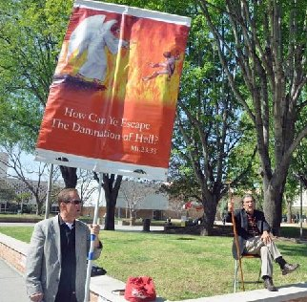
Pastor Jack and Banner
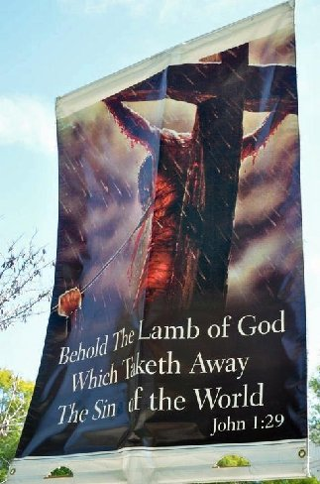
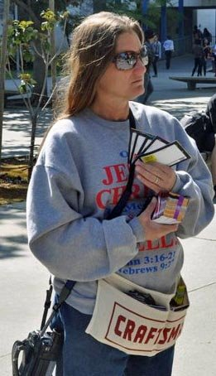
Pastor Jack's Wife Passing Out Tracts.

I started preaching at 12:30. About 30 gathered but shortly after classes started the crowd was dispersing. I turned the meeting over to Keith in the hopes that a new speaker would recapture their interest. However, a Christian butted in and started answering questions that several students standing by had directed towards me. It seems there is at least one on virtually every campus that thinks he can answer the questions better than I. It is rude interrupting someone else’s witness. The fellow did do a decent job in addressing the student’s questions. He did hold the attention of an Indian man for almost an hour.
Keith started the next break. He gathered another crowd. Keith is a good preacher. The class breaks are large and last at least fifteen minutes with a lot of traffic. I was a little concerned that Keith might not hold the crowd he had gathered since he was doing very little interaction with the students. I stepped up and Keith turned the meeting to me.
There was a girl in the audience who said she was a lesbian. After I expressed a feigned surprise, I asked, “Just what is it that lesbians do anyway?”
In talking about “gay issues” the subject of what gays do is rarely addressed. The talk usually centers on gay rights and whether they are born gay or chose gayness. Gays do some really disgusting things with their bodies. Romans chapter 1 of the King James Bible speaks of so called gay love as “vile affections.”
“Women did change the natural use into that which is against nature. . . And men burned in their lust one toward another; men with men working that which is unseemly (shameful).”
This lesbian had no shame, few of them do. Those which are without have been “given over to a reprobate (debased) mind, to do those things which are not convenient (fitting).”--Rom 1:26-28.
The girl did not speak as circumspectly on what lesbians do as the KJV Bible. One would think that students should know that what they do does not fit. But they claim there is nothing wrong with homosexuality, that it is natural. “Animals do it,” so they say. Therefore, I have to either demonstrate with electrical cords or my fingers that what homosexuals do does not fit. I also exhibit what does fit. I have to speak to them as if they were 13. The lesbian stayed around for most of the afternoon.
I called on Keith again and he preached through another class break, building a crowd of well over a hundred. Finally, several students began to interact with Keith. At 4:35, he turned the meeting back to me. We left campus at 5:30.
At the end of the day I encouraged Keith to slow down in his delivery. He speaks very fast. It would be good if Keith could spend some time with the Texan, Rick Bradley. He is so slow speaking with his Texas draw that student’s have to hang on to every word if they are going to get his message. I also encouraged him to interact more with the crowd, which is the key to getting and holding students’ attention. Keith appreciated my critique.
Martha did her sorority girl who met the devil routine. Some applauded her. The students were actually relatively civil on this campus. In my last session students seemed to think that I was gentler than Keith. I liked being considered the nice guy for a change. Keith did tell the students that all men are born into the world under the wrath of God, which I think most would perceive as harsh. I explained that is a view that some Christians hold but not I. I explained that Keith and I agreed on the fundamentals of the faith such as the virgin birth, the death and the resurrection of Jesus Christ and that he is the only way to salvation.
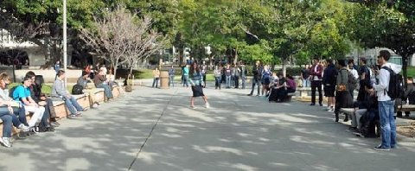
Martha at Cal State Fullerton

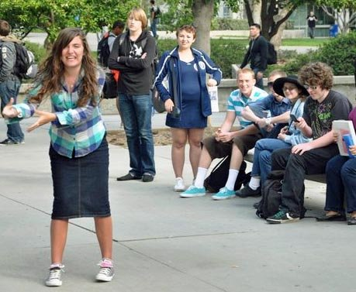

Free Speech if You Have a Badge

Long Beach State University, March 2, 2011

One has to sign in at the office of Student Life and Development at this campus. One has to wear a badge showing one’s name. Martha and I
There is a free speech platform in front of the bookstore. The problem is that it is set back somewhat from the main flow of traffic. There was a man with Greek letters, who confessed to being an agnostic. I rebuked him rather sharply. I offended him, but before he wanted to shake hands with me.
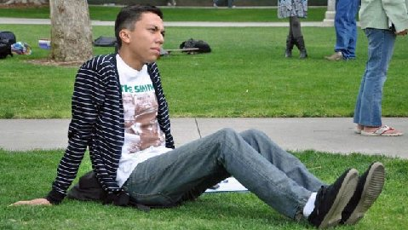
Long Beach State Listener
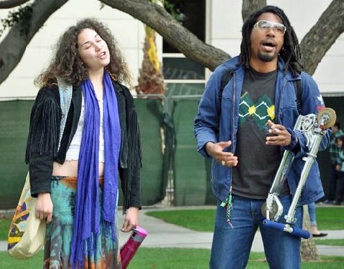
Students Disagree with the Message
I stirred up a group of Christians, who were on the grassy area singing songs and offering to pray for students. I had not been preaching long when they surrounded me like flies. One of the girls informed me that I was grieving the Holy Spirit. None of them believe that I was showing love. And they all wanted to excuse sin. During my interaction with them, I also communicated with an atheist who was only having sex with one girl. I also talked with a Deist. I responded, “Your deism is at least a start.” The professing Christians were so preoccupied with me they never attempted to reach out to the two atheists or the deist.
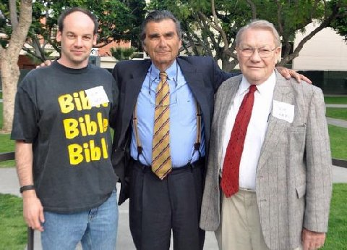
Pastor Dean Harvey on the far right and his grandson Jason on the left. Notice the nametags that the University made them wear.
After an hour the encounter with the Christians died out. By this time Dean Harvey, international teacher for YWAM, arrived with his grandson, Jason.
Also, Robert Ramos, one of my oldest Christian friends arrived. Robert heard me as an undergraduate at L.B. State in the 70’s. He says that I profoundly affected his life. Whenever, I came to Southern California over the decades Robert joined me on various campuses. Before, Cindy and I were married Robert followed Cindy around on Southern California campuses. Robert calls her Sinless Cindy. Robert had cornered Dean and was asking him all sorts of questions. Robert can be frustrating until one gets to know him and realize that he does have a sharp intellect and is a deep thinker. He has long passages of the Bible memorized. It took me a few years to really get to appreciate Robert for he does have a unique personality. And he is eccentric. But I rather enjoy people that are very different, even though until one gets to know them they can be a trial. It is hard to believe that Robert is 55. He has never married and he takes care of his elderly mother. Robert still calls me, “Mr. Smock.”
I went back to my car to get my list of sins sign. When I preached, I strayed from the designated area to get closer to the students, which enabled me to draw a lively crowd at the next break. A policewoman came out who was perturbed at me for being where I was not supposed to be. I complied and went back to the platform and some of the students followed me over. When the policewoman was instructing Martha on the rules, she discovered that neither Dean nor Jason had badges. Then Dale Parks came on the scene with a large banner. The policewoman made the three of them go to the office and get their badges.
There were a few students that were very vulgar, disrespectful and crude. However, most were civil and listening. One of the love bugs approached one of the ones who had been cursing me. The love bug was taken aback when the vituperative sinner swatted the love bug.
At about 4 PM I called on Dean. I did not get the opportunity to hear him since Natalie cornered me with some questions. She did not want to marry nor have children since she had been abused as a child and she had diseased genes. I told her no sex than. She said that will never happen. I took some time with her since she was sweet. I taught her on how wonderful the gift of life is. And I exhorted her to have more respect for her body. I told her that God was so great that he could heal her of her emotional and physical problems. I had to excuse myself at 4:30 since I had a dinner appointment with Pastor bob BIBLE and a church meeting at 7:30. I told Natalie that I wanted to pray for her and asked her to hold the other end of the Bible as I prayed. The Holy Ghost was upon me as I prayed. I trust that I will see her in heaven some day.
The police had stayed on to keep an eye on things. I thanked them as I left for their service.

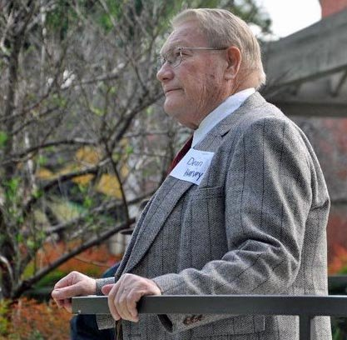
Pastor Dean Harvey, International Teacher for YWAM
THE DEBATE
UC Irvine March 3, 2011
Keith, the Presbyterian, Jack, the Baptist and his wife and I met once again to evangelize. The first break I did not draw a crowd. However, at the second break about 50 stopped. The Agnostic, Atheist and Rationalist Club passed out fliers informing the students of the scheduled debate between Stevie Ray Fromstein (a producer, writer and comedian) and Brother Jed on the Nature of Existence at 7 PM.
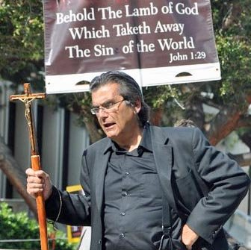
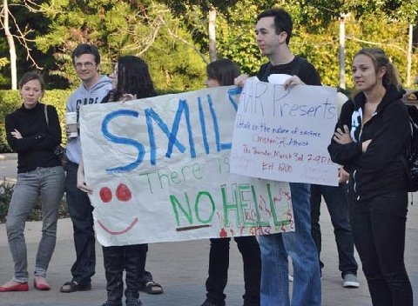
Unfortunately, you don't have to believe in Hell to go there!
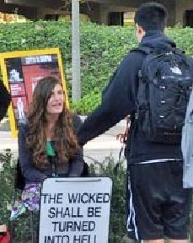
Martha Has a Sideline Conversation
Keith preached for an hour and then I finished up about 5 PM. The debate actually began 7:15 PM. It was held in a large lecture hall with about 75 in attendance. Stevie wanted an informal free flowing debate with each of us only giving 8 minute introductory speeches. Then he wanted to open it up for questions and interruptions. I think Stevie perceived his strength to be in questioning, a prosecutor, if you will. I would have preferred a more formal debate with longer opening statements and two rebuttals before opening things up. But I can adapt to most any situation, besides Stevie had arranged the debate, plus he is a likeable person so I agreed to all these terms. There was a female atheist graduate of UC who moderated. She was fair and forceful, which I like in a moderator.
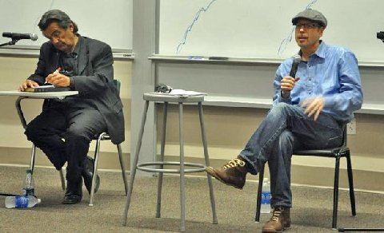
Stevie Ray Fromstein and Bro. Jed Smock Debate the Nature of Existence
Stevie made his opening statement sitting down. I stood up and moved around teaching that Christianity gives the most coherent, reasonable and consistent answer to the basic questions of life. Then the format was opened up to questions. Stevie asked virtually all the questions. I did not mind because I have the answers. And I enjoy defending God. Someone once said to me God needs no defense. Well, that may be; nevertheless, I think he appreciates it when his children defend his character, which is always being maligned by the devil’s children.
Stevie claimed that Christianity is simply an outgrowth of pagan religions which offered sacrifices to appease the wrath of their deities. His understanding is that Christianity teaches that Christ’s sacrifice was made to appease the wrath of God. I explained that this is an erroneous view of Christ’s atonement. But that I would need some time to develop the right view of the atonement. I related the story of King Zelucus, who puts out one of his own eyes to atone for the sin of his son, which illustrates the governmental view. After I finished the story, Stevie interrupted me with questions so I never had the opportunity to explain the parallel or tie it in with the governmental view. Hopefully, some in the audience understood the principle of atonement in the story without me explaining what Christ did on the cross.
Stevie seems to believe that mans’ behavior is determined by his genetic makeup. I defended free will. Stevie wanted to blame God for man’s disobedience, claiming that man’s design must have been faulty. I responded that men have abused their minds and bodies by using their bodies and faculties selfishly and contrary to God’s plan.
Around 8 PM Stevie made a remarkable admission, “I feel that I am losing the debate.” At this time the moderator stepped in with a few questions for me. And then with questions from the audience who had submitted their queries in writing. I do well at giving short answers. I probably made a mistake in telling the Zelucus’ story since it was a little long. If Stevie and I have a rematch, perhaps I will ask him more questions. After all, atheists do not have intelligible answers to the basic questions of life. Questions give me an opportunity to give answers. Stevie ended the debate at 9 PM by graciously thanking me for the contest and he expressed his appreciation that I did not give knee jerk responses to questions even from unbelievers. Of course, it helps to be on the side of truth.
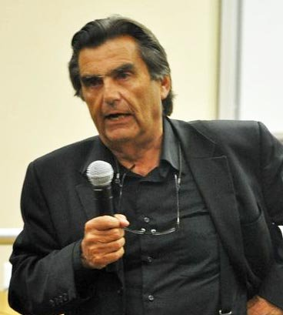
"...Christianity gives the most coherent, reasonable and consistent answer to the basic questions of life...."
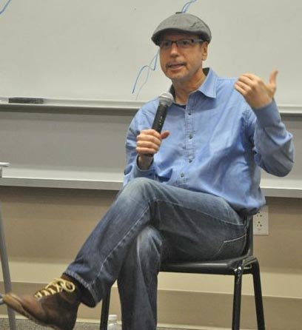
“I feel that I am losing the debate.”
Keith posted on my facebook wall, “I'm the Presbyterian and was with Jed at the debate. In all aspects - organization, oratory, rhetoric, argument, etc., - Jed was the clear "winner." If you have seen Jed on campus, then imagine a respectful student asking Jed questions and Jed giving answers to a captive audience.
At one point, the moderator and the debater made a comment about it not being a platform for Jed, but it was too late.
Several of the atheists behind me complimented Jed to me and later to him.”

A SOUL DRAMATICALLY SAVED

UC San Diego March 4, 2011

Dennis and his wife Victoria, who are our hosts this week, accompanied us to campus. Dennis is a country and gospel singer, who is associated with Billy and Franklin Graham.
Intervarsity had a large tent next to the free speech area in which people were to write on a 3 by 5 cards their deepest secrets. My preaching opened with a heated exchange with a fellow who accused me of idolatry by carrying my new staff crucifix. He said, “You look like the Pope.”
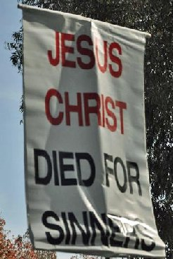

I hoped to use my argument with him to build a crowd. But that did not develop. There were two men listening to our dispute so I asked them if they were Christians. They indicated that they were. They were members of Campus Crusade for Christ.
They questioned me on the effectiveness of my methods and sandwich board sign, which lists sins. They feared the sign would turn people off. They wondered if there was ever any fruit from my ministry.
Meanwhile, Ryan stopped to listen. He was really focused on me and my sign. I asked, “Are you a Christian?”
“I hope so,” he answered.
“Are you doing any of the things listed on this sign?”
“Yes,” he confessed.
“Sin separates men from God and will result in Hell. Would you be willing to forsake all sin?” I asked.
Much to my surprise he answered that he was willing.
I inquired, “Are you willing to fully commit your life to Jesus Christ?”
“Yes, But there is a heavy cost in doing that,” he insightfully responded.
“I am glad to hear you say so, you are absolutely right. It costs everything to follow Christ. It may cost you your life. The opportunity for us to be saved cost Jesus his life. At the very least you have to give up your life of sin”
“Are you willing to do to make that decision right here and now?”
“Yes,” he replied with tears in his eyes.
“Over here is a man who is associated with Billy Graham. He has prayed with multitudes to receive Jesus as Lord and Savior. He will consul and pray with us for you to take this costly step.”
Dennis had been listening to my witness so he was ready. He and Ryan and I knelt on the sidewalk. Dennis led Ryan in a sinner’s prayer. Ryan was sobbing while Dennis advised him and exchanged contact information.
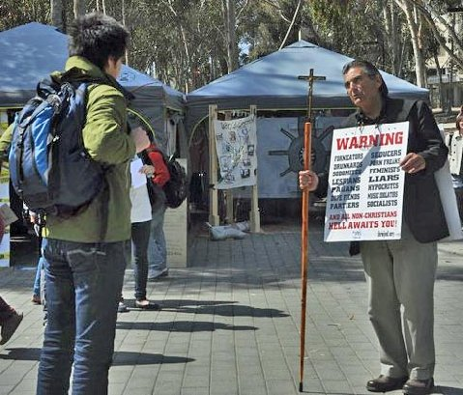
Ryan listening to the message.
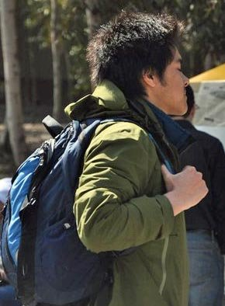
Conviction!
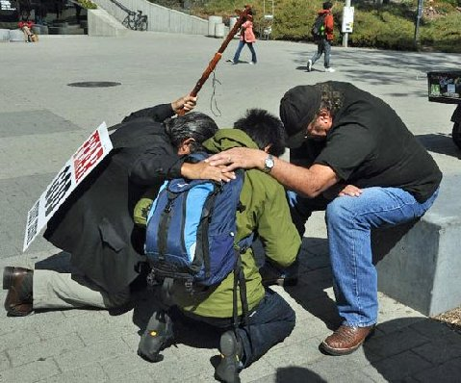
Prayer of Faith!
I returned to the Campus Crusaders with whom I had been conversing. They admitted that the Lord has shown them something. They acknowledged that they needed to be more open to confrontational evangelism.
By the middle of the afternoon, I was able to build a crowd primarily as a result of answering questions from an atheist. There was a half hour in which I felt that the spirit was really moving upon my audience of 20-25. After I challenged the theist, he admitted that it was virtually incomprehensible that something could come out of nothing.
I responded, “But the concept of an Almighty God, the Causeless cause, speaking the world into existence is comprehensible. Life coming from the Eternal makes more sense than life coming from non-life. Intelligence coming from a supremely intelligent everlasting personality is comprehendible.”
Since there were a number of Christians listening and witnessing (including Neil who twice a week comes to UCSD carrying a banner), the crowd eventually broke up into small groups discussing spiritual issues.
I walked through the Intervarsity tent. As I left a boy asked, “Are you the one criticizing students on this campus? Who do you think you are to come to our campus and criticize us?”
“I am a man of God, a preacher, and it is my job to expose sin.” He was yelling. He confessed, “I like to have sex with men?” Since he was unashamed, I announced, “Hey, be careful everyone this man is a homosexual. He is headed for Hell.”
I thought that I might use him to regain the attention of students. However, this man was so boisterous that I walked away from him twice. Each time he approached me again claiming I had no right to tell him he was headed for Hell. He claimed he was going to have me removed from campus. I was not too concerned about that since I was in the free speech zone.
Suddenly, the spirit of the Lord came upon Martha and she came out of nowhere as far at the students were concerned for she had not yet spoken today. Martha rebuked the homo saying, “You are the one who is harassing the preacher he has walked away from you twice and you keep badgering him.” Eventually, Martha revealed to him that she was my daughter. Martha confronting the student shocked those that were in the area and she gathered a group around her and she ended up having a calm conversation with the pervert.
Corey, who last year made a short documentary of me for a class at Cal State Fullerton, came out to campus today to start work on a full length documentary on my life and ministry. He has another man helping him. He will be following me around for the next week. He said that he got a lot of good footage today. Unfortunately, he did not have his cameras set up in time to record the conversion of Ryan.
Having Dennis with me today may have made the difference in the conversion of Ryan. Dennis has anointing in which he leads large numbers to the Lord weekly as he travels the world evangelizing and singing gospel music.

Jed, I forgot to tell you... when you spoke at Cal State Fullerton... I had to leave early before you and the others finished preaching.
As I walked to my car I passed many students - and you and the other preachers were the subject of every... conversation I overheard as I walked to my car.
The conversations weren't mocking. They were heated and convicted.
I don't think I have ever seen the students at CSF so stirred up on a single topic.
K. S.
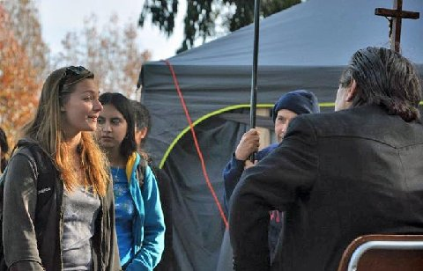
Thank you for your faithful prayers and support. Please continue to pray for us. You may donate to CMUSA using PayPal by going to our web site brojed.org or by mailing your check to our home address: CMUSA 2402 Longview Dr. Columbia, MO 65203. All gifts are tax deductible. Thank you for your generosity.

